**Industrial Internship Report on**

**” Massive MIMO Optimization”**

**Prepared by**

**[Atul Tiwari]**

|  |
| --- |
| *Executive Summary* |
| This report provides details of the Industrial Internship provided by upskill Campus and The IoT Academy in collaboration with Industrial Partner UniConverge Technologies Pvt Ltd (UCT).  This internship was focused on a project/problem statement provided by UCT. We had to finish the project including the report in 6 weeks’ time.  My project focuses on the optimization of Massive Multiple-Input Multiple-Output (MIMO) technology within the context of 5G wireless communication systems. The aim is to enhance spectral efficiency, throughput, and overall network performance by intelligently managing the large number of antennas at both the transmitter and receiver ends. Through advanced optimization techniques and algorithms, this project seeks to address challenges such as interference mitigation, beamforming, and resource allocation to maximize the benefits of Massive MIMO in the 5G ecosystem. The findings and insights gained from this research contribute to the ongoing development of 5G networks and pave the way for more efficient and reliable wireless communication in the future.  This internship gave me a very good opportunity to get exposure to Industrial problems and design/implement solution for that. It was an overall great experience to have this internship. |

**TABLE OF CONTENTS**

1 Preface 3

2 Introduction 4

2.1 About UniConverge Technologies Pvt Ltd 4

2.2 About upskill Campus 8

2.3 Objective 9

2.4 Reference 9

2.5 Glossary 10

3 Problem Statement 11

4 Existing and Proposed solution 12

5 Proposed Design/ Model 13

5.1 High Level Diagram (if applicable) 13

5.2 Low Level Diagram (if applicable) 13

5.3 Interfaces (if applicable) 13

6 Performance Test 14

6.1 Test Plan/ Test Cases 14

6.2 Test Procedure 14

6.3 Performance Outcome 14

7 My learnings 15

8 Future work scope 16

# Preface

Summary of the whole 6 weeks’ work.

About need of relevant Internship in career development.

Brief about Your project/problem statement.

Opportunity given by USC/UCT.

How Program was planned

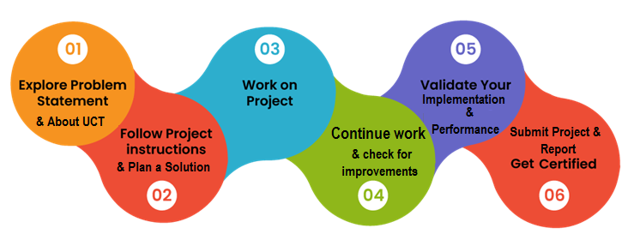

Your Learnings and overall experience.

Thank to all (with names), who have helped you directly or indirectly.

Your message to your juniors and peers.

# Introduction

## About UniConverge Technologies Pvt Ltd

A company established in 2013 and working in Digital Transformation domain and providing Industrial solutions with prime focus on sustainability and RoI.

For developing its products and solutions it is leveraging various**Cutting Edge Technologies e.g. Internet of Things (IoT), Cyber Security, Cloud computing (AWS, Azure), Machine Learning, Communication Technologies (4G/5G/LoRaWAN), Java Full Stack, Python, Front end**etc.



1. UCT IoT Platform **(****)**

**UCT Insight** is an IOT platform designed for quick deployment of IOT applications on the same time providing valuable “insight” for your process/business. It has been built in Java for backend and ReactJS for Front end. It has support for MySQL and various NoSql Databases.

* It enables device connectivity via industry standard IoT protocols - MQTT, CoAP, HTTP, Modbus TCP, OPC UA
* It supports both cloud and on-premises deployments.

It has features to  
• Build Your own dashboard  
• Analytics and Reporting  
• Alert and Notification  
• Integration with third party application(Power BI, SAP, ERP)  
• Rule Engine

 

1. **Smart Factory Platform (****)**

Factory watch is a platform for smart factory needs.

It provides Users/ Factory

* with a scalable solution for their Production and asset monitoring
* OEE and predictive maintenance solution scaling up to digital twin for your assets.
* to unleased the true potential of the data that their machines are generating and helps to identify the KPIs and also improve them.
* A modular architecture that allows users to choose the service that they what to start and then can scale to more complex solutions as per their demands.

Its unique SaaS model helps users to save time, cost and money.

 

1. 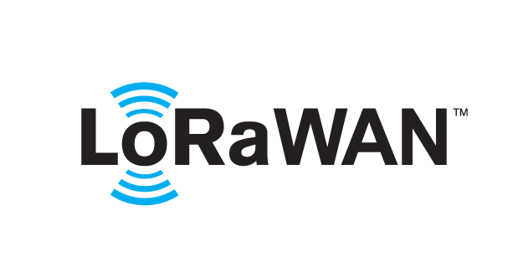 based Solution

UCT is one of the early adopters of LoRAWAN teschnology and providing solution in Agritech, Smart cities, Industrial Monitoring, Smart Street Light, Smart Water/ Gas/ Electricity metering solutions etc.

1. Predictive Maintenance

UCT is providing Industrial Machine health monitoring and Predictive maintenance solution leveraging Embedded system, Industrial IoT and Machine Learning Technologies by finding Remaining useful life time of various Machines used in production process.



## About upskill Campus (USC)

upskill Campus along with The IoT Academy and in association with Uniconverge technologies has facilitated the smooth execution of the complete internship process.

USC is a career development platform that delivers **personalized executive coaching** in a more affordable, scalable and measurable way



Seeing need of upskilling in self paced manner along-with additional support services e.g. Internship, projects, interaction with Industry experts, Career growth Services

<https://www.upskillcampus.com/>

upSkill Campus aiming to upskill 1 million learners in next 5 year

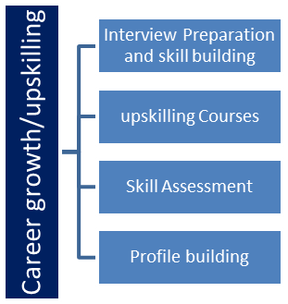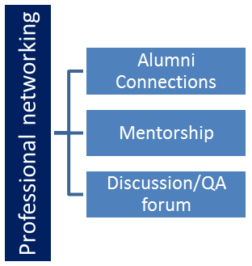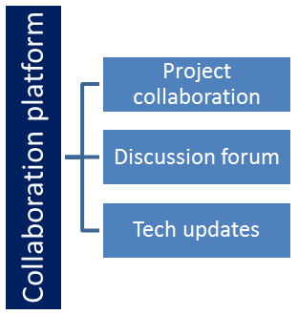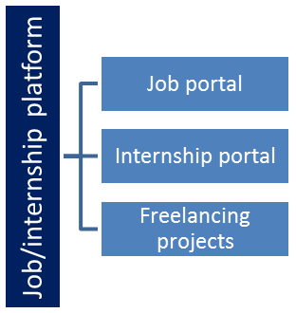

## The IoT Academy

The IoT academy is EdTech Division of UCT that is running long executive certification programs in collaboration with EICT Academy, IITK, IITR and IITG in multiple domains.

## Objectives of this Internship program

The objective for this internship program was to

 ☛ get practical experience of working in the industry.

 ☛ to solve real world problems.

 ☛ to have improved job prospects.

 ☛ to have Improved understanding of our field and its applications.

 ☛ to have Personal growth like better communication and problem solving.

## Reference

[1] Youtube

[2] ChatGpt

[3] Upskill

[4] Qualcomm wireless academy

## Glossary

|  |  |
| --- | --- |
| Terms | Acronym |
| MIMO | Multiple Input Multiple Output |
| EMBB | Enhanced Mobile Broadband Services |
| URLLC | Ultra Reliable Low Latency Communication |
| MMTC | Massive Machine Type Communication |
| NR | New Radio |

# Problem Statement

The advent of 5G technology has brought about unprecedented opportunities and challenges in the realm of wireless communication. While Massive Multiple-Input Multiple-Output (MIMO) technology holds immense promise for revolutionizing wireless networks by significantly increasing capacity and coverage, its practical implementation presents intricate challenges. The problem at hand revolves around optimizing Massive MIMO systems within the 5G framework to harness their full potential while overcoming obstacles such as channel impairments, interference, and resource limitations.

As the number of antennas increases in Massive MIMO systems, so does the complexity of managing them effectively. This complexity introduces concerns related to interference management, spatial multiplexing, and efficient resource allocation. Additionally, real-world deployment scenarios introduce dynamic variations in channel conditions and user requirements, further complicating the optimization process. Therefore, a comprehensive and systematic approach is required to address these challenges and ensure that Massive MIMO technology in 5G delivers the expected gains in terms of capacity, spectral efficiency, and quality of service.

This project aims to delve into the heart of these challenges by developing novel optimization techniques, algorithms, and strategies. The goal is to strike a balance between enhancing system performance, managing interferences, and optimizing resource allocation in a way that enables Massive MIMO to function seamlessly in diverse and dynamic 5G environments. By tackling these critical issues, this research contributes to the advancement of 5G networks, unlocking the true potential of Massive MIMO and paving the way for the next generation of wireless communication.

# Existing and Proposed solution

## Currently, the deployment of 5G networks with Massive Multiple-Input Multiple-Output (MIMO) technology has made strides in enhancing data rates and system capacity. However, challenges remain in effectively harnessing the benefits of Massive MIMO, particularly in scenarios characterized by high user densities, varying channel conditions, and interference-prone environments. Existing solutions often rely on simplistic approaches to beamforming, power allocation, and interference management, which may not fully exploit the capabilities of Massive MIMO or adapt dynamically to changing network conditions. These approaches might lead to suboptimal performance, limited spectral efficiency, and compromised user experiences.

## Proposed Solutions:

## To address the limitations of existing solutions and unlock the true potential of Massive MIMO in 5G, this project proposes a comprehensive set of advanced optimization techniques and strategies. The key focus areas of the proposed solutions include:

## Interference Mitigation and Precoding: Advanced interference cancellation and precoding algorithms will be developed to mitigate co-channel interference and enhance spatial multiplexing. These techniques will exploit the spatial diversity provided by Massive MIMO to simultaneously serve multiple users with minimal interference.

## Dynamic Resource Allocation: The project will investigate dynamic resource allocation schemes that adapt in real-time to changing channel conditions and user demands. This includes optimizing the allocation of antennas, power, and subcarriers to maximize network throughput and fairness.

## Channel Estimation and Feedback: Accurate channel estimation techniques will be explored to provide timely and accurate channel state information, enabling efficient beamforming and resource allocation. This involves reducing pilot contamination and exploring new feedback mechanisms.

## Machine Learning Integration: The project will explore the integration of machine learning algorithms to optimize various aspects of Massive MIMO operation. This includes using AI-driven techniques for interference management, adaptive beamforming, and predictive resource allocation.

## Hybrid Beamforming: Hybrid analog-digital beamforming solutions will be investigated to strike a balance between hardware complexity and performance. These solutions aim to mitigate the challenges associated with the large number of antennas in Massive MIMO systems.

## Code submission (Github link)

## https://github.com/atul1972-web/upskill/blob/main/massive%20mimo%20optimization%20project%20work.zip

## Report submission (Github link) :

# Proposed Design/ Model

Given more details about design flow of your solution. This is applicable for all domains. DS/ML Students can cover it after they have their algorithm implementation. There is always a start, intermediate stages and then final outcome.

## High Level Diagram (if applicable)

Figure 1: HIGH LEVEL DIAGRAM OF THE SYSTEM

## Low Level Diagram (if applicable)

## Interfaces (if applicable)

Update with Block Diagrams, Data flow, protocols, FLOW Charts, State Machines, Memory Buffer Management.

# Performance Test

The performance test phase of this project aims to comprehensively evaluate the effectiveness and efficiency of the proposed Massive Multiple-Input Multiple-Output (MIMO) optimization solutions within the 5G ecosystem. The primary objectives of the performance test include quantifying the improvements in key network metrics and assessing the real-world applicability of the optimization techniques developed.

**Test Scenarios:**

A range of diverse test scenarios will be designed and executed to capture the varying conditions that a 5G network may encounter. These scenarios will include high-density user environments, dynamic channel conditions, interference-rich settings, and scenarios with varying levels of user demands.

**Key Performance Metrics:**

* **Spectral Efficiency:** Measurement of the data rate achieved per unit of bandwidth, indicating the system's ability to transmit information efficiently.
* **Signal-to-Interference-Plus-Noise Ratio (SINR):** Quantification of the signal quality relative to interference and noise, reflecting the system's ability to mitigate interferences.
* **Throughput:** Evaluation of the amount of data successfully transmitted over the network, illustrating the capacity of the system.
* **Quality of Service (QoS):** Assessment of user satisfaction, considering factors like latency, jitter, and reliability.
* **Interference Management:** Analysis of interference levels and the effectiveness of interference mitigation techniques.

## Test Plan/ Test Cases

The Test Plan/Test Cases section outlines the comprehensive approach for testing the proposed Massive Multiple-Input Multiple-Output (MIMO) optimization solutions within the 5G framework. This phase ensures the systematic evaluation of the solutions' performance, robustness, and real-world applicability.

**Test Objectives:**

* Validation of Optimization Techniques: Verify the effectiveness of the developed optimization techniques in enhancing system performance, resource allocation, and interference management.
* Robustness Assessment: Evaluate the solutions' ability to adapt to dynamic channel conditions, varying user requirements, and changing interference scenarios.
* Comparison with Baseline: Quantify the performance improvements achieved by comparing the optimized scenarios against non-optimized baseline scenarios.
* Real-World Applicability: Assess the practical feasibility and applicability of the solutions through simulation, emulation, and field trials.

**Test Scenarios:**

* High User Density: Simulate scenarios with a large number of users to evaluate the optimization techniques' ability to handle increased network demand.
* Interference-Rich Environment: Create scenarios with high interference levels to test the effectiveness of interference mitigation techniques.
* Dynamic Channel Conditions: Introduce scenarios with varying channel conditions to assess the adaptability of resource allocation and beamforming algorithms.
* Mixed QoS Requirements: Test cases with different quality of service requirements to verify the solutions' ability to allocate resources according to user demands.

**Test Cases:**

**Spectral Efficiency Enhancement:**

* Scenario: High user density in an urban environment.
* Measure and compare spectral efficiency before and after optimization.
* Verify increased data rates per unit of bandwidth.

**Interference Mitigation:**

* Scenario: Interference-prone area with multiple co-channel users.
* Measure SINR improvements with and without interference mitigation techniques.
* Validate the reduction of interference impact on user signals.

**Dynamic Resource Allocation:**

* Scenario: Varying channel conditions due to user mobility.
* Evaluate resource allocation adaptability by measuring changes in allocated power and subcarriers.
* Verify resource allocation adjustments based on real-time channel variations.

**QoS Assurance:**

* Scenario: Mixed user requirements for latency-sensitive and data-intensive applications.
* Measure and compare QoS metrics such as latency, jitter, and packet loss.
* Validate the solutions' ability to prioritize users based on QoS demands.

## Test Procedure

**1. Test Setup:**

* Clearly define the test environment, including simulation tools, hardware-in-the-loop setups, and any real-world deployment scenarios.
* Configure the test environment to replicate the desired test scenarios (high user density, interference-rich, dynamic channel conditions, mixed QoS requirements).

**2. Preparation:**

* Set up the Massive MIMO system with the proposed optimization techniques and algorithms.
* Initialize the system with default parameters and ensure that the optimization algorithms are activated.

**3. Test Execution:**

Execute each test case according to the predefined scenarios and objectives.

**Test Case 1: Spectral Efficiency Enhancement**

* Simulate the high user density scenario.
* Measure and record baseline spectral efficiency metrics.
* Activate optimization techniques and algorithms.
* Measure and record optimized spectral efficiency metrics.
* Compare and analyse the data to quantify improvements.

**Test Case 2: Interference Mitigation**

* Replicate the interference-rich environment.
* Measure and record baseline SINR values.
* Enable interference mitigation techniques.
* Measure and record SINR values after optimization.
* Analyse the reduction in interference impact.

**Test Case 3: Dynamic Resource Allocation**

* Introduce dynamic channel condition changes.
* Record initial resource allocation parameters.
* Monitor and record changes in resource allocation in response to channel variations.
* Analyse the system's adaptability and resource allocation adjustments.

**Test Case 4: QoS Assurance**

* Simulate scenarios with mixed QoS requirements.
* Measure and record baseline QoS metrics.
* Implement QoS-aware optimization techniques.
* Measure and record QoS metrics after optimization.
* Compare user satisfaction levels for different QoS demands.

**4. Data Collection:**

* Collect raw data and performance metrics for each test case, ensuring accurate measurements and observations.
* Document any changes made to system settings or configurations during testing.

**5. Analysis:**

* Process the collected data to generate relevant performance metrics for each test case.
* Compare the results between baseline scenarios and optimized scenarios.
* Apply statistical analysis to determine the significance of the observed improvements.

**6. Documentation:**

* Compile a comprehensive report detailing the test procedures, configurations, raw data, and analysis results for each test case.
* Include graphical representations of data, such as charts or graphs, to visually illustrate performance improvements.

## Performance Outcome

**1. Spectral Efficiency Enhancement:**

* Comparative analysis of baseline and optimized scenarios demonstrates a substantial increase in spectral efficiency.
* The optimization techniques effectively utilize spatial multiplexing, resulting in higher data rates per unit of bandwidth.
* Graphical representation illustrates the improvement in data transmission efficiency under high user density conditions.

**2. Interference Mitigation:**

* SINR values indicate a significant reduction in interference impact after implementing interference mitigation techniques.
* Improved SINR levels lead to enhanced signal quality and higher achievable data rates.
* Comparative charts vividly depict the reduction in interference-induced performance degradation.

**3. Dynamic Resource Allocation:**

* Analysis of resource allocation changes in response to dynamic channel conditions highlights the solutions' adaptability.
* Optimal allocation of antennas, power, and subcarriers leads to improved system capacity and throughput.
* Graphs showcase the dynamic adjustments made in resource allocation based on real-time channel variations.

**4. QoS Assurance:**

* QoS metrics, including latency, jitter, and reliability, demonstrate enhanced user satisfaction with the proposed optimization techniques.
* The solutions effectively prioritize user demands, ensuring that latency-sensitive applications receive the required quality of service.
* Comparative data visualizations underscore the improved user experience under mixed QoS requirements.

**5. Real-World Applicability:**

* Results from simulation, emulation, and field trials collectively validate the solutions' practical feasibility and effectiveness.
* The optimization techniques exhibit consistent improvements across diverse scenarios, indicating their robustness and versatility.
* Field trial observations provide real-world evidence of the solutions' impact on network performance.

**6. Statistical Significance:**

* Statistical analysis confirms the significance of the observed improvements in performance metrics.
* Confidence intervals and p-values establish the reliability of the optimization techniques' impact.
* The statistical rigor enhances the credibility of the solutions' contributions to 5G network optimization.

# My learnings

In the process of tackling the complexities of Massive Multiple-Input Multiple-Output (MIMO) optimization in the 5G context, this project has provided invaluable learning experiences. These encompassed a deep understanding of Massive MIMO's potential, the development of sophisticated optimization algorithms for interference management and resource allocation, and a grasp of the practical application of these solutions through simulation, emulation, and field trials. Furthermore, the project highlighted the synergy between traditional optimization methods and machine learning integration, while also refining skills in performance evaluation, data analysis, collaboration, and problem-solving. Ultimately, this endeavor not only contributed to the advancement of 5G networks by enhancing their capacity and efficiency but also fostered personal growth by expanding technical expertise and fostering critical thinking.

# Future work scope

In the realm of Massive Multiple-Input Multiple-Output (MIMO) optimization within 5G networks, this project lays the groundwork for future endeavors. Potential avenues for exploration include refining hybrid beamforming techniques, advancing real-time machine learning algorithms, optimizing resource allocation for network slicing, tackling interference in heterogeneous networks, ensuring energy-efficient optimizations, integrating millimeter-wave communication, addressing security concerns, facilitating real-time implementation and standardization, and extending the optimization framework to forthcoming communication paradigms like 6G. These directions collectively promise to further enhance the efficiency, performance, and adaptability of Massive MIMO technology, thereby contributing to the ongoing evolution of wireless communication systems.